**SIU_Clockwise_Orchestrate Bidirectional Requirements**

**Version 1.0**

**Prepared By: Lois Whitley & Levy Lazarre**

**Date: 8/20/2019**

Document Control 3

Resources: 3

Document Version Control 3

1. Introduction 4

1.1 Purpose 4

1.2 Project Scope 4

1.3 Terminology Standards 4

1.3.1 Acronyms 4

1.3.2 Glossary 4

1.4 Document References 5

2. Diagram 6

3. Core Requirements 8

3.1 Cloverleaf Functional Requirements 8

3.2 Cerner FSI Functional Requirements 9

3.3 Non-Functional Requirements 9

3.4 Messaging Protocols 10

3.4.1 Protocol From or to Vendor 10

3.4.2 FSI Comm Server Names 10

4. HL7 Messaging 11

4.1 Messaging Format 11

4.1.1 Segments 11

4.1*.*2 Messaging Event Types 11

4.1*.*3 Cloverleaf Configuration Files 12

4.1.4 Cloverleaf Site Location 12

4.1.5 Cerner FSI Impacted Scripts 12

4.2 Data Transformation Requirements 13

4.3 Sample Message 13

4.3.1 Inbound to Cloverleaf from Clockwise 13

4.3.2 Outbound from Cloverleaf to Orchestrate 13

4.3.3 Inbound to Cloverleaf from Orchestrate 13

4.3.4 Outbound from Cloverleaf to Clockwise 14

5. Alerts 16

Appendix A: Risks, Concerns & Issues 16

# **Document Control**

## Resources:

Project Distribution List*:* (include Project Team Members, Liaisons, Vendor Contacts, etc.)

|  |  |  |
| --- | --- | --- |
| **Name** | **Role** | **Email** |
| Levy Lazarre | Integration Analyst | [Levy.Lazarre@baycare.org](mailto:Levy.Lazarre@baycare.org) |
| Susan M Clay | IS Project Manager | [Sue.Clay@baycare.org](mailto:Sue.Clay@baycare.org) |
| Dan DeBruler | Software Engineering Manager, DocuTap | ddbruler@docutap.com |
| Andrew Skvarca | Integration Analyst II, Teletracking | Andrew-Skvarca@teletracking.com |
| Scott Spence | Manager, Tech OPR Outreach Lab - SJH Outreach | [Scott.Spence@baycare.org](mailto:Scott.Spence@baycare.org) |
| Donna Swetnich | SR Systems Analyst, Applications Ancillary | [Donna.Swetnich@baycare.org](mailto:Donna.Swetnich@baycare.org) |
| Rick Wattras | Software Engineer, Datica | rick@datica.com |
| Daniel Alicea | Manager, Applications, IS Physician Revenue Cycle | [Daniel.Alicea@baycare.org](mailto:Daniel.Alicea@baycare.org) |
|  |  |  |

## Document Version Control

|  |  |  |  |
| --- | --- | --- | --- |
| **Version** | **Date** | **Modifier** | **Description** |
| V1.0 | 8/20/2019 | Lois Whitley | Originally Created |
| V1.1 | 8/28/2019 | Levy Lazarre | Completed Cloverleaf Requirements |
|  |  |  |  |
|  |  |  |  |

# 1. Introduction

## 1.1 Purpose

The purpose of this document is to describe the bidirectional scheduling interface between Clockwise and Orchestrate. Clockwise.MD is a “Patient Engagement Software Solution” from DocuTAP that allows patients to self-schedule, view current wait times on a display screen, receive text reminders and alerts. It is currently being used in BayCare Labs and customers can go to the BayCare web site and follow a “Save Your Spot” link to schedule a laboratory procedure.

The goal is to extend the use of Clockwise to other procedures like Radiology by implementing it in conjunction with TeleTracking Orchestrate. Orchestrate is a procedural throughput solution that takes an anticipated schedule and tracks the patient flow and procedural milestone processes in real time on the day of the procedure. It is a software solution from TeleTracking that is now called **Clinical Workflow Suite**.

## 1.2 Project Scope

Integration for this project includes a bidirectional Scheduling (SIU) interface between Clockwise and Orchestrate. With this integration, the patient can “Save Your Spot” in Clockwise, which then sends a scheduling message to Orchestrate. Orchestrate tracks the patient through the process and sends time stamp scheduling messages back to Clockwise throughout the process. (See workflow diagram below).

## 1.3 Terminology Standards

### 1.3.1 Acronyms

**SIU –** Scheduling Information Unsolicited; notifies an auxiliary application of changes to some facet of the filler application's appointment schedule.

### 1.3.2 Glossary

**Clockwise.MD** is the “Save Your Spot” application name.

**DocuTAP** is the vendor name.

**Orchestrate** is the former patient tracking application name. It is now called **Clinical Workflow Suite.**

**TeleTracking** is the vendor name.

**Clockwise Hospital –** refers to a distinct facility (like “Bloomingdale”). This is mapped to HL7 **PV1.3.4 (Facility).**

**Clockwise Line of Service –** refers to a Clockwise queue (like “LAB”). This is mapped to HL7 **PV1.3.1 (Point of Care).**

## 1.4 Document References

List all documents or Web addresses to which this IDBB refers; provide enough information so that the reader can access a copy of each reference. Include the title, author, version number, date, and source or location.

Documents found on SharePoint:

Orchestrate Interface Specifications on SharePoint

CWS Inbound Outbound Interface Specs

BayCare Health System Clockwise Integration

# 2. Diagram

Provide a solution diagram that depicts the integration of components specified in this IDBB. This diagram must include the data flow for the interfaces (source and target).

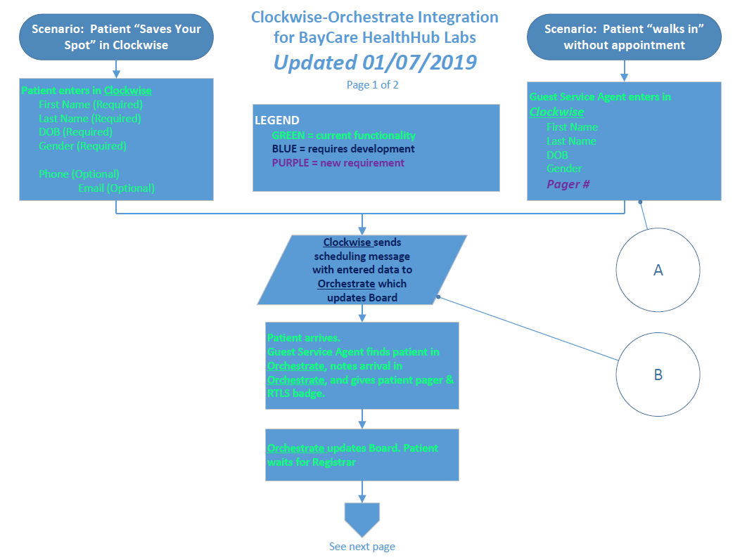

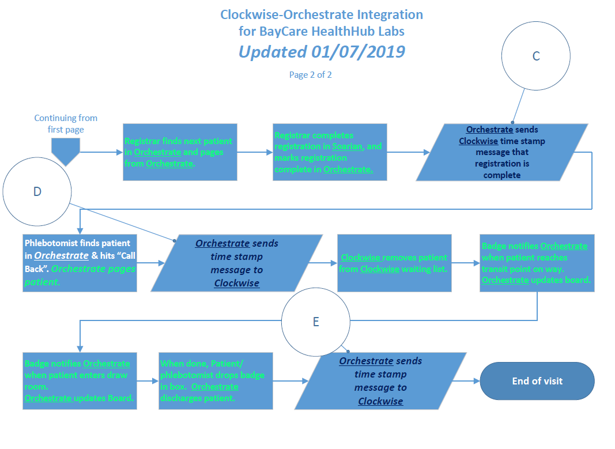

# 3. Core Requirements

## 3.1 Cloverleaf Functional Requirements

Provide detail for the below functional requirements. The message transformation requirements for the components defined in this specification should be specified in section 4.2 of this document.

|  |  |  |
| --- | --- | --- |
| **Cloverleaf** | | |
| **Number** | **Requirement Name** | **Description** |
| FR.2019.8.1 | Patient matching | Clockwise has no concept of identifiers like MRN, CPI, FIN… The patient match in this integration is based on patient demographics (last name, first name, date of birth), and appointment ID in SCH.5 of SIU messages. |
| FR.2019.8.2 | Patient Arrival | Patient “check-in” always occurs in Clockwise, which then sends a SIU^S12 message to Orchestrate to indicate that the patient has entered the facility. |
| FR.2019.8.3 | Milestone messages | As the patient moves in and out of procedure rooms, Orchestrate will track the patient and send to Clockwise “milestone” messages that are SIU^S14 messages with a special “event code” in OBX.3. |
| FR.2019.8.4 | OBX.3 timer “event codes” | 31119.0 - Arrived in facility  8555.4 – Registration Complete in Orchestrate  111.2 - Enter Proc Room  -111.2 - Leave Proc Room  116.5 - Patient Discharged |
|  |  |  |
|  |  |  |
|  |  |  |
|  |  |  |

## 3.2 Cerner FSI Functional Requirements

|  |  |  |
| --- | --- | --- |
| **Cerner FSI** | | |
| **Number** | **Requirement Name** | **Description** |
| FR.2019.X.1 |  |  |
|  |  |  |
|  |  |  |
|  |  |  |
|  |  |  |
|  |  |  |
|  |  |  |
|  |  |  |

## 3.3 Non-Functional Requirements

Provide concise detail for the below non-functional requirements. This would include external table ownership, hours of support, etc. The below requirements must be evaluated for every project.

|  |  |  |
| --- | --- | --- |
| **Number** | **Requirement Name** | **Description** |
| NFR.2019.X.1 |  |  |
|  |  |  |
|  |  |  |
|  |  |  |
|  |  |  |

## 3.4 Messaging Protocols

Below are listed the details for the messaging protocols that will be leveraged for this integration. This includes: TCP/IP, FTP, Web Services, etc.

### 3.4.1 Protocol From or to Vendor

|  |  |
| --- | --- |
| FTP |  |
| MLLP Socket Connection (TCP/IP) |  |
| Local File Drop by Midrange Team |  |
| Other | Click here to enter text. |

### 3.4.2 FSI Comm Server Names

|  |  |
| --- | --- |
| Names | Click here to enter text. |
|  |  |

# 4. HL7 Messaging

## 4.1 Messaging Format

### 4.1.1 Segments

The segments utilized for this interface are:

MSH

SCH

PID

[PV1]

OBX

RGS

AIS

AIP

*Message Construction Notes:*

*[Square Brackets] – Optional*

*{Curly Brackets} – Repeatable*

*MSH – Message Header*

*SCH – Schedule Activity Info segment*

*PID – Patient ID segment*

*PV1 – Patient Visit segment*

*OBX – Observation/Result segment*

*RGS – Resource Group segment*

*AIS – Appointment Info – Service segment*

*AIP – Appointment Info – Personnel Resource segment*

*[{ – Start of optional, repeatable group*

*}] – End of optional, repeatable group*

### 4.1*.*2 Messaging Event Types

Below are the messages types necessary for this integration

|  |  |
| --- | --- |
| **Event Type** | **Description** |
| S12 | New Appointment |
| S13 | Appointment Rescheduling |
| S14 | Appointment Modification |
| S15 | Cancellation of Appointment |

### 4.1*.*3 Cloverleaf Configuration Files

No Cloverleaf transformation scripts or translates were used, as the HL7 messages are sent raw in this bidirectional interface.

### 4.1.4 Cloverleaf Site Location

teletrck_24 (TEST), teletrck_24_p (Prod)

### 4.1.5 Cerner FSI Impacted Scripts

## 4.2 Data Transformation Requirements

There were no transformations necessary for this integration. The SIU messages were sent “raw” from and to Clockwise/Orchestrate.

## 4.3 Sample Message

### 4.3.1 Inbound to Cloverleaf from Clockwise

MSH|^~\&|Clockwise|baycare|||20190820131503||SIU^S15|427458d7-490e-4f2d-a3ee-b8277afb8fd5|T|2.3  
SCH|||||274116||Lab - Adult Test||||1^^^20190820090000||||||||||||||  
PID|1||^^^^||Outreach^Scott^||19771113||||||||eng|||||||||||||||  
PV1|||LAB^^^LAB^^^||||||||||||||||^^^^|||||||||||||||||||||||||||||||274116  
RGS|1||  
AIS|1|||||||||  
AIP|1|||||||||||

### 4.3.2 Outbound from Cloverleaf to Orchestrate

MSH|^~\&|Clockwise|baycare|||20190820131503||SIU^S15|427458d7-490e-4f2d-a3ee-b8277afb8fd5|T|2.3  
SCH|||||274116||Lab - Adult Test||||1^^^20190820090000||||||||||||||  
PID|1||^^^^||Outreach^Scott^||19771113||||||||eng|||||||||||||||  
PV1|||LAB^^^LAB^^^||||||||||||||||^^^^|||||||||||||||||||||||||||||||274116  
RGS|1||  
AIS|1|||||||||  
AIP|1|||||||||||

### 4.3.3 Inbound to Cloverleaf from Orchestrate

MSH|^~\&|HRC-WFS||||20190812151120||SIU^S14|0000000016|P|2.3|||AL|NE

SCH|||||5897948||CAB^CT ABDOMEN WITHOUT CONTRAST||||^^^20190311093000|||||||||^Admin^User

PID|||||TIGER^LINDSAY||19840317|F

PV1||O|||||||||||||||||6000143115

OBX|||111.2||20190812150544||||||

RGS|

AIS|1||

### 4.3.4 Outbound from Cloverleaf to Clockwise

MSH|^~\&|HRC-WFS||||20190812151120||SIU^S14|0000000016|P|2.3|||AL|NE  
SCH|||||5897948||CAB^CT ABDOMEN WITHOUT CONTRAST||||^^^20190311093000|||||||||^Admin^User  
PID|||||TIGER^LINDSAY||19840317|F  
PV1||O|||||||||||||||||6000143115  
OBX|||111.2||20190812150544||||||  
RGS|  
AIS|1||

This is the recording of a testing session on a walk-in patient on 08/15/2019 showing the flow and interpretation of messages…

**Patient added as walk-in in Clockwise --> S12 sent to Orchestrate**

MSH|^~\&|Clockwise|baycare|||20190815171352||SIU^S12|24745160-882c-414a-aad2-93f1ec2c9890|T|2.3

SCH|||||272687||||||1^^^20190815131351||||||||||||||

PID|1||^^^^||Outreach^Scott^||19771113||||||||eng|||||||||||||||

PV1|||LAB^^^LAB^^^||||||||||||||||^^^^|||||||||||||||||||||||||||||||272687 <--- PV1.50 (Alternate Visit ID is not retained by Orchestrate and not sent back to Clockwise in future messages)

RGS|1||

AIS|1|||||||||

AIP|1|||||||||||

**Patient moved to registration in Orchestrate --> S14 sent to Clockwise --> No action in Clockwise (expected)**

MSH|^~\&|HRC-WFS|Bloomingdale|||20190815131425||SIU^S14|0000000042|P|2.3|||AL|NE

SCH|||||272687||||||^^^20190815131351|||||||||SXS49494^Spence^Scott

PID|||||Outreach^Scott||19771113|U

OBX|||31119.0||20190815131425||||||

RGS|

AIS|1||

**Patient registration marked as complete in Orchestrate --> S14 sent to Clockwise --> “Ready” button in Clockwise change from No to Yes on Patient Queue screen (expected)**

MSH|^~\&|HRC-WFS|Bloomingdale|||20190815131709||SIU^S14|0000000043|P|2.3|||AL|NE

SCH|||||272687||||||^^^20190815131351|||||||||SXS49494^Spence^Scott

PID|||||OUTREACH^SCOTT||19771113|M

PV1|||||||||||||||||||6000145207

OBX|||8555.4||20190815131709||||||

RGS|

AIS|1||

**Patient moved into Lab room 1 (Procedure Room aka Exam Room) in Orchestrate --> S14 sent to Clockwise --> Patient “Called Back” in Clockwise and moved from Waiting room area to Exam room area – Nurse screen (expected)**

MSH|^~\&|HRC-WFS|Bloomingdale|||20190815131854||SIU^S14|0000000044|P|2.3|||AL|NE

SCH|||||272687||||||^^^20190815131351|||||||||SXS49494^Spence^Scott

PID|||||OUTREACH^SCOTT||19771113|M

PV1|||||||||||||||||||6000145207

OBX|||111.2||20190815131854||||||

RGS|

AIS|1||

**Patient moved to Departure in Orchestrate --> S14 sent to Clockwise --> Patient Discharged in Clockwise (expected)**

MSH|^~\&|HRC-WFS|Bloomingdale|||20190815132024||SIU^S14|0000000045|P|2.3|||AL|NE

SCH|||||272687||||||^^^20190815131351|||||||||SXS49494^Spence^Scott

PID|||||OUTREACH^SCOTT||19771113|M

PV1|||||||||||||||||||6000145207

OBX|||-111.2||20190815132024||||||

RGS|

AIS|1||

# 5. Alerts

Are you going to need alerting on this connection?

|  |  |
| --- | --- |
| Yes |  |
| No |  |

If the answer is yes, please complete the table below:

|  |  |  |  |
| --- | --- | --- | --- |
| **Site Name** | **Hours of Support** | **Distribution Group** | **Comments** |
|  |  |  |  |
|  |  |  |  |

# Appendix A: Risks, Concerns & Issues

|  |  |  |  |
| --- | --- | --- | --- |
| **Project Name** | |  | |
| **Number** | **Risk/Concern/Issue** | **Comment** | **Mitigation** |
|  |  |  |  |
| RCI.2019.1.0 |  |  |  |
|  |  |  |  |
|  |  |  |  |
|  |  |  |  |

* End of document